|  |  |  |  |  |  |
| --- | --- | --- | --- | --- | --- |
| **Nama Motor** | **Harga Motor** | **Kapasitas Mesin** | **Kapasitas Tangki Bahan Bakar** | **Daya Maks** | **Torsi Maks** |
| Beat | 16665000 | 109,5 | 4,2 | 6,6 | 9,3 |
| Vario 125 | 21005000 | 124,8 | 5,5 | 8,2 | 10,8 |
| Vario 150 | 24715000 | 149,3 | 5,5 | 9,7 | 13,4 |
| Scoopy | 20325000 | 109,5 | 4,2 | 6,6 | 9,3 |
| Xride 125 | 18840000 | 125 | 4,2 | 7 | 9,6 |
| Freego | 19275000 | 125 | 4,2 | 7 | 9,5 |
| Mio M3 125 | 16500000 | 125 | 4,2 | 7 | 9,6 |
| Cost/benefit | Cost | Benefit | Benefit | Benefit | Benefit |
| Bobot kriteria | 0,30 | 0,25 | 0,25 | 0,10 | 0,10 |

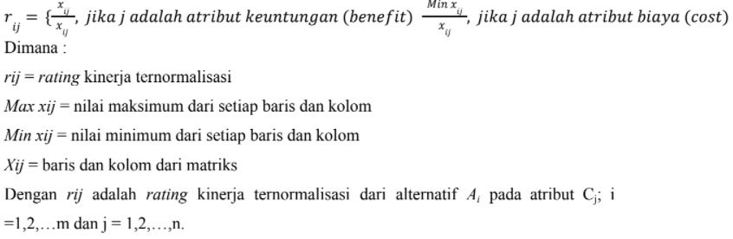**PERHITUNGAN MANUAL DATA DENGAN METODE SAW**

Normalisasi Data

r11= min {harga motor}/16665000=16500000/16665000= 0.9900

r21= min {harga motor}/21005000=16500000/21005000= 0.7855

r31= min {harga motor}/24715000=16500000/24715000= 0.6676

r41= min {harga motor}/20325000=16500000/20325000= 0.8118

r51= min {harga motor}/18840000=16500000/18840000= 0.8757

r61= min {harga motor}/19275000=16500000/19275000= 0.8560

r71= min {harga motor}/16500000=16500000/16500000= 1

r12= 109,5/max {kapasitas mesin} =109,5/149,3 = 0.7334

r22= 124,8/max {kapasitas mesin} =124,8/149,3 = 0.8359

r32= 149,3/max {kapasitas mesin} =149,3/149,3 = 1

r42= 109,5/max {kapasitas mesin} =109,5/149,3 = 0.7334

r52= 125/max {kapasitas mesin} =125/149,3 = 0.8372

r62= 125/max {kapasitas mesin} =125/149,3 = 0.8372

r72= 125/max {kapasitas mesin} =125/149,3 = 0.8372

r13= 4,2/max {kapasitas tangki} =4,2/5,5 = 0.7636

r23= 5,5/max {kapasitas tangki} =5,5/5,5 = 1

r33= 5,5/max {kapasitas tangki} =5,5/5,5 = 1

r43= 4,2/max {kapasitas tangki} =4,2/5,5 = 0.7636

r53= 4,2/max {kapasitas tangki} =4,2/5,5 = 0.7636

r63= 4,2/max {kapasitas tangki} =4,2/5,5 = 0.7636

r73= 4,2/max {kapasitas tangki} =4,2/5,5 = 0.7636

r14= 6,6/max {daya maks} =6,6/9,7 = 0.6804

r24= 8,2/max {daya maks} =8,2/9,7 = 0.8453

r34= 9,7/max {daya maks} =9,7/9,7 = 1

r44= 6,6/max {daya maks} =6,6/9,7 = 0.6804

r54= 7/max {daya maks} =7/9,7 = 0.7216

r64= 7/max {daya maks} =7/9,7 = 0.7216

r74= 7/max {daya maks} =7/9,7 = 0.7216

r15= 9,3/max {daya maks} =9,3/13,4 = 0.6940

r25= 10,8/max {daya maks} =10,8/13,4 = 0.8059

r35= 13,4/max {daya maks} =13,4/13,4 = 1

r45= 9,3/max {daya maks} =9,3/13,4 = 0.6940

r55= 9,6/max {daya maks} =9,6/13,4 = 0.7164

r65= 9,5/max {daya maks} =9,5/13,4 = 0.7089

r75= 9,6/max {daya maks} =9,6/13,4 = 0.7164

hasil normalisasi

|  |  |  |  |  |
| --- | --- | --- | --- | --- |
| 0.9900 | 0.7334 | 0.7636 | 0.6804 | 0.6940 |
| 0.7855 | 0.8359 | 1 | 0.8453 | 0.8059 |
| 0.6676 | 1 | 1 | 1 | 1 |
| 0.8118 | 0.7334 | 0.7636 | 0.6804 | 0.6940 |
| 0.8757 | 0.8372 | 0.7636 | 0.7216 | 0.7164 |
| 0.8560 | 0.8372 | 0.7636 | 0.7216 | 0.7089 |
| 1 | 0.8372 | 0.7636 | 0.7216 | 0.7164 |

Selanjutnya perhitungan preverensi

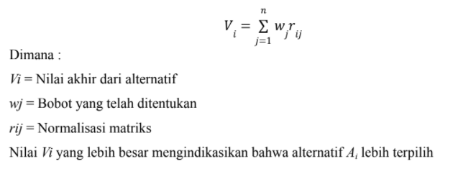

V1 = (0,30)(0,9900)+ (0,25)(0,7334)+ (0,25)(0,7636)+ (0,10)(0,6804)+ (0,10)(0,6940) = 0.80869

V2 = (0,30)(0,7855)+ (0,25)(0,8359)+ (0,25)(1)+ (0,10)(0,8453)+ (0,10)(0,8059) = 0.859745

V3 = (0,30)(0,6676)+ (0,25)(1)+ (0,25)(1)+ (0,10)(1)+ (0,10)(1) = 0.90028

V4 = (0,30)(0,8118)+ (0,25)(0,7334)+ (0,25)(0,7636)+ (0,10)(0,6804)+ (0,10)(0,6940) = 0.75523

V5 = (0,30)(0,8757)+ (0,25)(0,8372)+ (0,25)(0,7636)+ (0,10)(0,7216)+ (0,10)(0,7164) = 0.80671

V6 = (0,30)(0,8560)+ (0,25)(0,8372)+ (0,25)(0,7636)+ (0,10)(0,7216)+ (0,10)(0,7089) = 0.80005

V7 = (0,30)(1)+ (0,25)(0,8372)+ (0,25)(0,7636)+ (0,10)(0,7216)+ (0,10)(0,7164) = 0.8440